**Lab: -** 1

**Tile of the problem:** Prime Number

**Test Case Analysis:**

|  |  |
| --- | --- |
| **Input** | **Output** |
| 5 | Prime |
| 9 | Not a prime |
| 11 | Prime |

**Coding:**

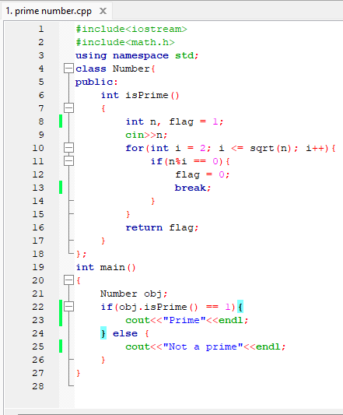

**Result:**

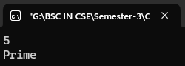 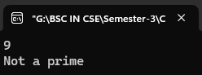 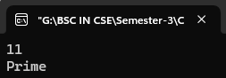

**Justification of the output:**

1. **Input**: 5

**Output**: Prime

**Justification**: 5 is greater than 1 and has no positive divisors other than 1 and itself. It is not divisible by any number other than 1 and 5, so it is a prime number.

1. **Input**: 9

**Output**: Not a Prime

**Justification**: 9 is greater than 1 but it has divisors other than 1 and itself. Specifically, 9 is divisible by 3 (since 3 × 3 = 9). Therefore, it is not a prime number.

1. **Input**: 11

Justification: 5 is greater than 1 and has no positive divisors other than 1 and itself. It is not divisible by any number other than 1 and 5, so it is a prime number.